**ASSIGNMENT - 1**

**NATURAL LANGUAGE PROCESSING**

**PRIYANSHU SHARMA**

**15BCE1282**

**POS TAGGING**

**CODE**

import nltk

from nltk.corpus import state_union

from nltk.tokenize import PunktSentenceTokenizer

train_text = state_union.raw("2005-GWBush.txt")

sample_text = state_union.raw("2006-GWBush.txt")

custom_sent_tokenizer = PunktSentenceTokenizer(train_text)

tokenized = custom_sent_tokenizer.tokenize(sample_text)

def process_content():

try:

for i in tokenized:

words = nltk.word_tokenize(i)

tagged = nltk.pos_tag(words)

print(tagged)

except Exception as e:

print(str(e))

process_content()

**OUTPUT**

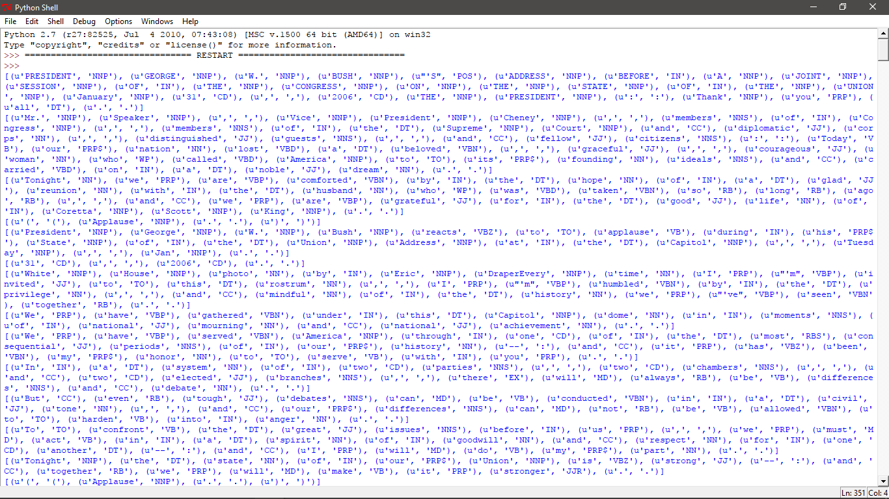

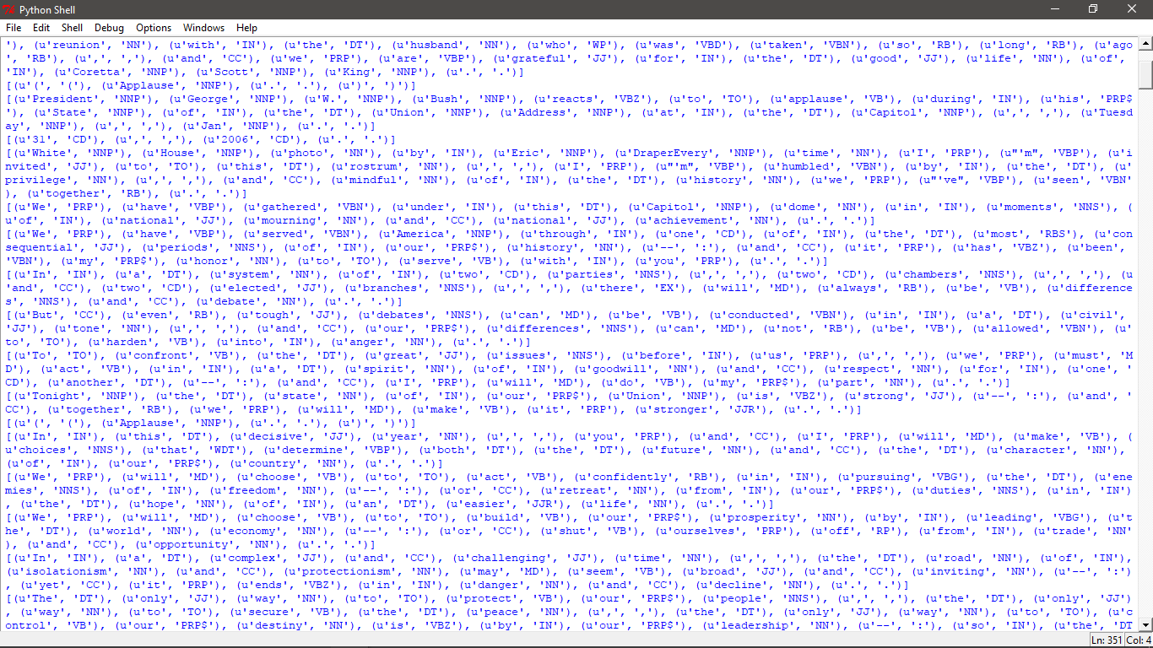

**SENTENCE SEGMENTATION**

**CODE**

from nltk.tokenize import sent_tokenize, word_tokenize

example_text = "Hello Mr. Priyanshu! How are you? My first paper is on Monday, and I am really happy."

print(sent_tokenize(example_text)) #sentence segmentation

print(word_tokenize(example_text)) #word by word segmentation

for i in word_tokenize(example_text): #print all the segmenated word

print(i)

**OUTPUT**

